- Single step through the program created in the previous assignment (HW3)—the AddSub Program. Submit a trace of screenshots single stepping through each line of the program.
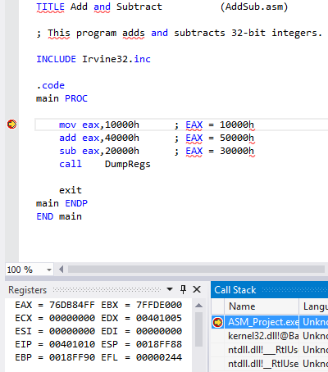 | 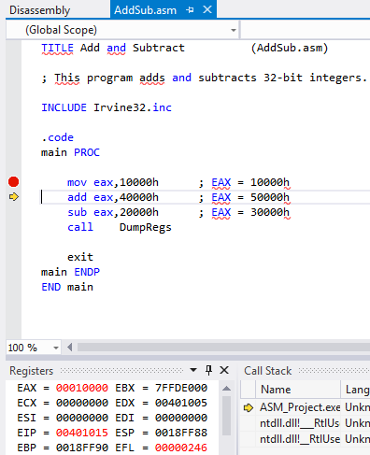
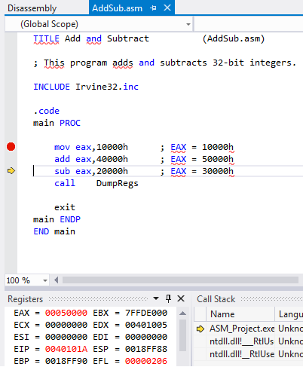 | 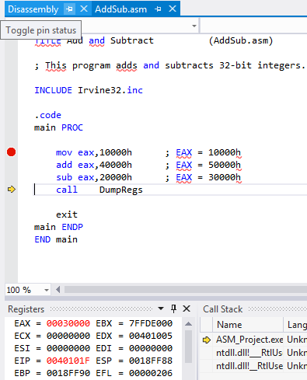
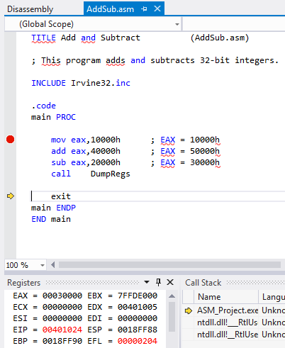

- Declare whether each flag is set (‘1’ for set, ‘0’ for not set) following each instruction. Show the function of the instructions by hand.

Instruction # | Instruction | CF | SF | ZF | OF
0 | mov ax, 7F00h
1 | add ax, 100h | 1 | 0 | 0 | 0
2 | add al, 0h | 0 | 0 | 1 | 0
3 | add al, 0FFh | 0 | 0 | 0 | 0
4 | sub ah, 080h | 0 | 0 | 1 | 0

- Given the following data declarations:

.data
Alpha BYTE 2Bh, 23h, 4Ah
Beta DWORD 222h
Delta DWORD 312h
Iota DWORD 434h
Zeta WORD 124h

- Write an instruction that moves Beta into EAX and adds Iota to the same register
mov EAX, Beta
add EAX, Iota
- Write a set of instructions that adds all the elements of the array Alpha into AL
;Method One
.data
Alpha BYTE 2Bh, 23h, 4Ah
.code
mov esi, OFFSET Alpha
mov AL, [esi];2B
add AL, [esi+1];4E
add AL, [esi+2];98

;Method Two (Indirect Operands)
.data
Alpha BYTE 2Bh, 23h, 4Ah
.code
mov esi, OFFSET Alpha
mov AL, [esi];2B
INC esi
add AL, [esi];4E
INC esi
add AL, [esi];98

;Method Three (Loop)
.data
Alpha BYTE 2Bh, 23h, 4Ah
.code
mov edi, OFFSET Alpha
mov ecx, LENGTHOF Alpha
mov AL, 0
L1:
add AL, [edi]
add edi, TYPE Alpha
loop L1
- Write a set of instructions that moves Delta into EAX, adds the value stored in Zeta to the same register
.data
Delta DWORD 312h
Zeta WORD 124h
.code
mov EAX, Delta;EAX = 312h
add AX, Zeta;EAX = 436h
- Write an instruction that moves the last two bytes in ALPHA into CX.
.data
Alpha BYTE 2Bh, 23h, 4Ah
.code
movzx CX, Alpha+2

- What are the contents of CX subsequent to part D of this question?
CX = 0000

- Fill in the requested register values after executions of the instructions:
Show the memory map. NOTE: Whoever created the question forgot to place a ‘0’ to the beginning AACCh, BCCBh, AB71h, BB00h.
.data
myBytes BYTE 24h, 25h, 26h, 27h
myWords WORD 2233h, 3355h, 3456h, AACCh, BCCBh
myDoubles DWORD BB00h, 2345h, 3456h, AB71h, 44h
myPointer DWORD myDoubles

.code
mov esi, OFFSET myBytes
mov ax, WORD PTR [esi+2] ; A. AX = 2726
mov eax, DWORD PTR myWords ; B. EAX = 33552233
mov esi, myPointer
mov ax, WORD PTR [esi+8] ; C. AX = 3456
mov ax, WORD PTR [esi+1] ; D. AX = 00BB
mov ax, WORD PTR [esi-6] ; E. AX = 3456
Memory Map
 | DWORD | WORD | BYTE | offset |  |  |  | DWORD | WORD | BYTE | offset
myBytes |  |  | 24 | 0 |  | myPointer | myDoubles | 0000BB00 | BB00 | 00 | 0
 |  |  | 25 | 1 |  |  |  |  |  | BB | 1
 |  |  | 26 | 2 |  |  |  |  | 0000 | 00 | 2
 |  |  | 27 | 3 |  |  |  |  |  | 00 | 3
 |  |  |  |  |  |  |  | 00002345 | 2345 | 45 | 4
myWords |  | 2233 | 33 | 0 |  |  |  |  |  | 23 | 5
 |  |  | 22 | 1 |  |  |  |  | 0000 | 00 | 6
 |  | 3355 | 55 | 2 |  |  |  |  |  | 00 | 7
 |  |  | 33 | 3 |  |  |  | 00003456 | 3456 | 56 | 8
 |  | 3456 | 56 | 4 |  |  |  |  |  | 34 | 9
 |  |  | 34 | 5 |  |  |  |  | 0000 | 00 | 10
 |  | AACC | CC | 6 |  |  |  |  |  | 00 | 11
 |  |  | AA | 7 |  |  |  | 0000AB71 | AB71 | 71 | 12
 |  | BCCB | CB | 8 |  |  |  |  |  | AB | 13
 |  |  | BC | 9 |  |  |  |  | 0000 | 00 | 14
 |  |  |  |  |  |  |  |  |  | 00 | 15
 |  |  |  |  |  |  |  | 00000044 | 0044 | 44 | 16
 |  |  |  |  |  |  |  |  |  | 00 | 17
 |  |  |  |  |  |  |  |  | 0000 | 00 | 18
 |  |  |  |  |  |  |  |  |  | 00 | 19

- What is returned by the following operations in connection to the given array:

.data
myArray DWORD 12 DUP(23), 3, 34, 467 , 2365, 47899

- TYPE myArray
4₁₀, 4₁₆

- LENGTHOF myArray
17₁₀, 11₁₆

- SIZEOF myArray
68₁₀, 44₁₆
- Fill in the requested register values after executions of the instructions (Do not let your eyes deceive you. There are some movSx instructions and some movZx instructions.):

.code
mov bx, 0ACD8h
movzx eax, bx ; A. EAX = 0000ACD8h
movzx edx, bl ; B. EDX = 000000D8h
movzx cx, bh ; C. CX = 00ACh

mov bx, 0DD34h
movsx eax, bx ; D. EAX = FFFFDD34
movsx edx, bl ; E. EDX = 00000034
movsx cx, bh ; F. CX = FFDD

Note: This is also in HW 3.
- Write a program that prints War Eagle on your screen. You can use the following. Assemble and generate the output using MASM and Visual Studio. Embed your output in your submission.
Source code:

Output:
TITLE PRINT WAR EAGLE
COMMENT !
This program prints "WAR EAGLE" on the screen
with a carriage return and line feed.
!

INCLUDE Irvine32.inc
.data
message BYTE "WAR EAGLE",0dh,0ah,0

.code
main PROC
mov edx, offset message
Call WriteString
exit

main ENDP

END main
WAR EAGLE
Press any key to continue . . .

